**THCIC CD Load**

1. Check Website for updates

<http://www.dshs.state.tx.us/thcic/hospitals/Inpatientpudf.shtm>

<http://www.dshs.state.tx.us/thcic/OutpatientFacilities/OutpatientPUDF.shtm>

1. Check Readme on CD for updates
2. Copy Tab Zip file from CD to Server: HV10/IQSC01, Extracted Zip files, and Rename Tab delimited files;
   1. InPatient to \\HV10\N:\PUDF\IP\Working and OutPatient to \\HV10\N:\PUDF\OP\Working.

For Example:

InPatient UDF_base1_3q2014.txt 🡪 PUDF_base1_IPworking.txt

InPatient PUDF_base2_3q2014.txt 🡪 PUDF_base2_IPworking.txt

InPatient PUDF_charges_3q2014.txt 🡪 PUDF_charges_IPworking.txt

InPatient Facility_type_3q2014.txt 🡪 Facility_type_IPworking.txt

OutPatient OP_PUDF_base_working.txt 🡪 OP_PUDF_base_working.txt

OutPatient OP_Classification_working.txt 🡪 OP_Classification_working.txt

OutPatient OP_Facility_type_working.txt 🡪 OP_Facility_type_working.txt

OutPatient OP_PUDF_charges_working.txt 🡪 OP_PUDF_charges_working.txt

1. Truncate Base1, base2, Facility_Type and Charges staging Inpatient tables in THCIC_DW database.

Truncate Base, Classification, Facility_Type and Charges staging Outpatient tables in THCIC_DW database.

On SSMS, please execute the following.

IP Tables :

1. Truncate table PUDF_base1_IPworking
2. Truncate table PUDF_base1_IPworking
3. Truncate table Facility_type_IPworking
4. Truncate table PUDF_charges_IPworking

OP Tables :

1. Truncate table OP_PUDF_base_working
2. Truncate table OP_Classification_working
3. Truncate table OP_Facility_type_working
4. Truncate table OP_PUDF_charges_working
5. Staging DB : THCIC_DW

Load Base1, base2 , Facility_Type and Charges staging tables from \\HV10\N:\PUDF\IP\Working

Load Base1, base2, Facility_Type and Charges staging tables from \\HV10\N:\PUDF\OP\Working

1. N:\ Scripts\PUDF Process\first step for IN patients.sql
2. N:\ Scripts\PUDF Process\first step for OUT patients.sql
3. **Validate Pre-Load Count** from Data Dictionary PDF on CD. See example below.

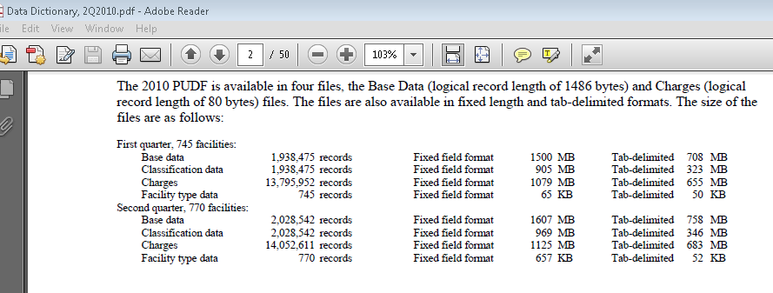

1. Load PUDF and Charges tables in THCIC_DW database from the staging tables.
   1. N:\Scripts\ PUDF_IP_Staging_Load.sql
   2. N:\Scripts\ PUDF_Charges_Staging_Load.sql
2. **Validate Load Count** from SSMS HV10\IQSC01.

USE THCIC_DW

GO

Select count(*) from PUDF_base1_IPworking

Select count(*) from PUDF_base2_IPworking

Select count(*) from Facility_type_IPworking

Select count(*) from PUDF_charges_IPworking

Select count(*) from OP_Facility_type_working

Select count(*) from OP_Classification_working

Select count(*) from OP_PUDF_base_working

Select count(*) from OP_PUDF_charges_working

If counts are off, please retry load starting from (Step 2).

1. Run SubmissionPurpose_Update Script.
   1. N:\Scripts\ SubmissionPurpose_Update.sql
2. Ask Ed to verify data in the staging tables. .
   1. Counts Before(Step 4) and After file load (Step 6)
   2. N:\Scripts\THCIC_Count_Validation.sql
3. Migrate PUDF and Charges tables from Staging: THCIC_DW to Production: THCIC
   1. N:\Scripts\Finalstep.sql